ITMAL

Hand-in: Journal 2

Af Gruppe 12

Gradient descent

## Qa:

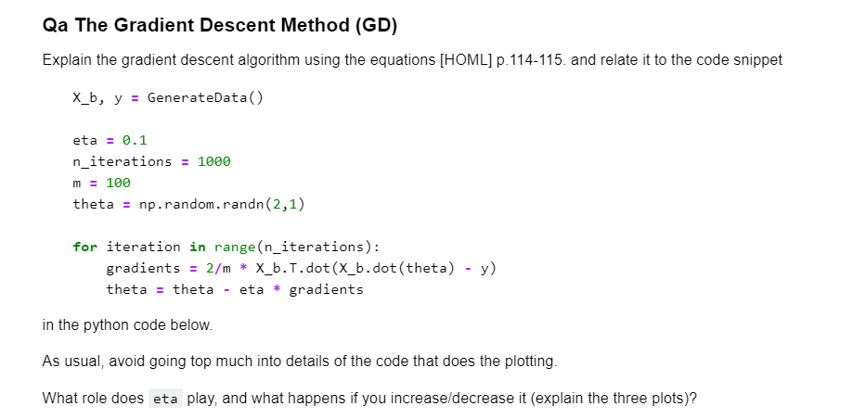

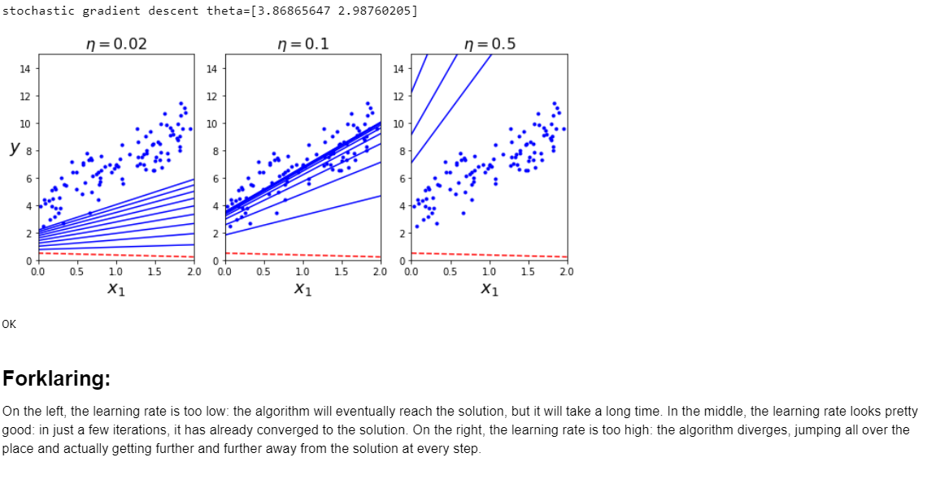

## Qb:

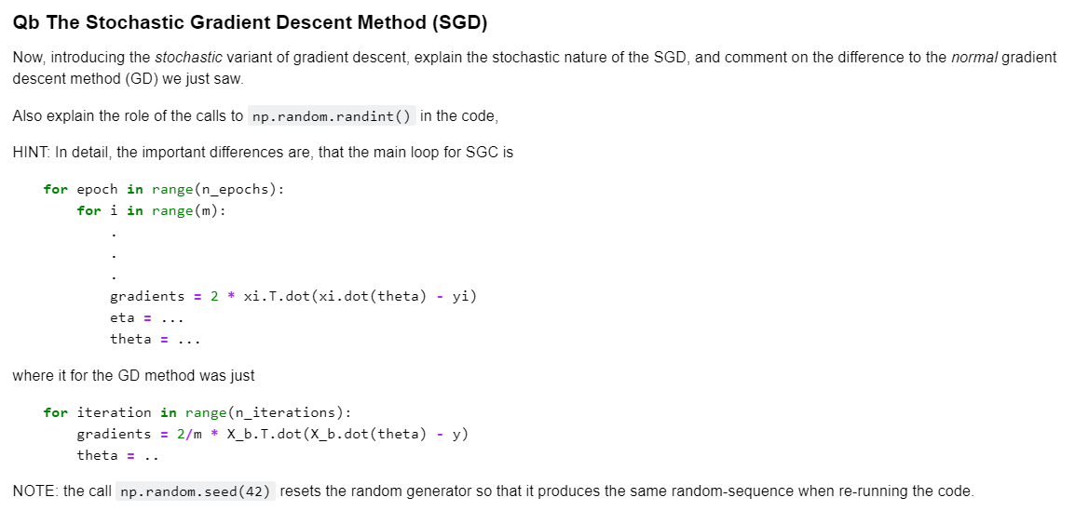

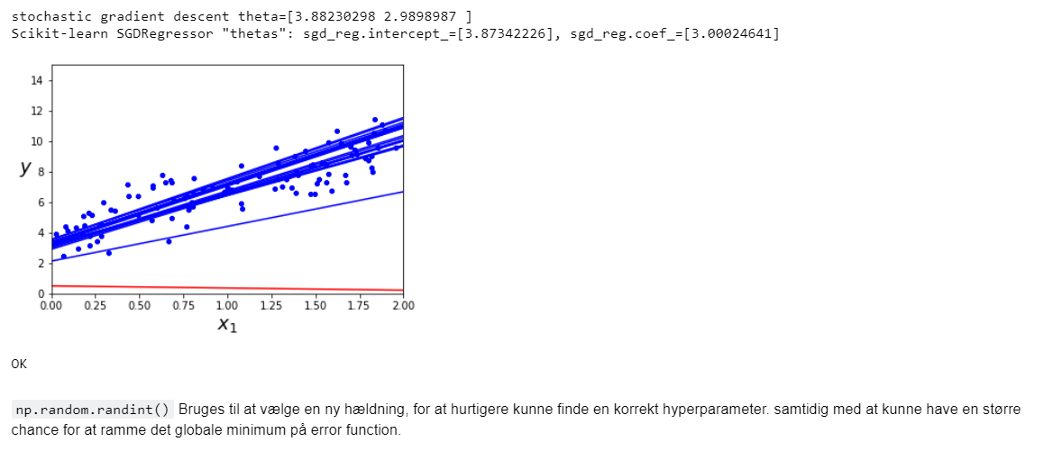

## Qd:

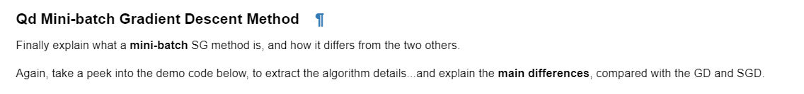

### Forklaring:

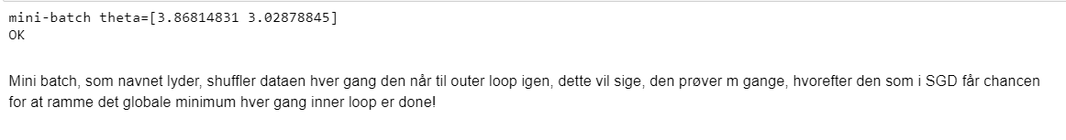

## Qe:



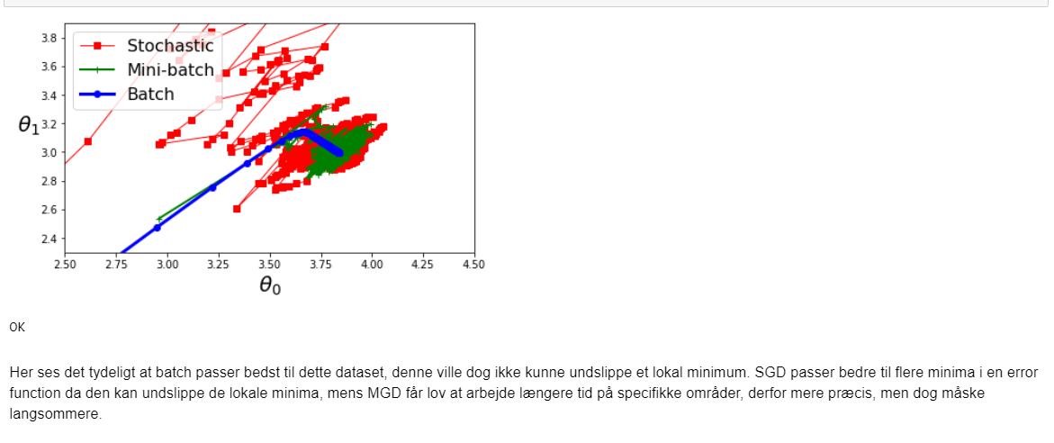

# Capacity under overfitting

## Qa:

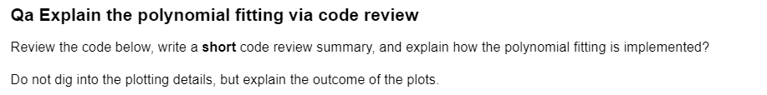

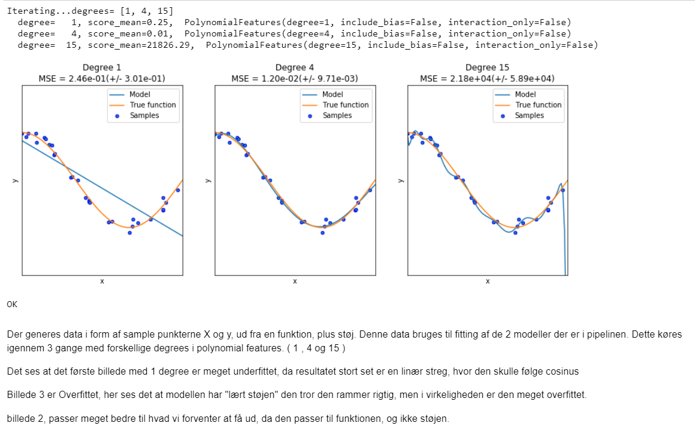

## Qb:

